**A.B.G.S. Recommended Summer Reading List!**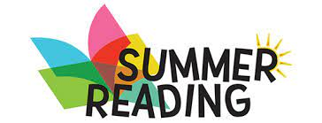

***A Good Kind of Trouble by*** Lisa Moore Ramee

***Crossover Series by*** Kwame Alexander

***Harry Potter and the Prisoner of Azkaban by*** J.K. Rowling

***Dork Diaries by*** Rachel Renee Russell

***Diary of a Wimpy Kid by*** Jeff Kinney

***Middle School Series by*** James Patterson

***Posted by*** John David Anderson

***The Star Beneath Our Feet by*** David Barclay Moore

***Goosebumps Series by*** R.L. Stine

***Forged by Fire by*** Sharon M. Draper

**Books by Authors:** Sharon Creech

Gordon Korean

Kate DiCamillo

Jerry Spinelli

Sharon Flake

Cynthia Rylant

**In partnership with Hempstead Public Library!**

**Hempstead Public Library**  
**115 James A. Garner Way**  
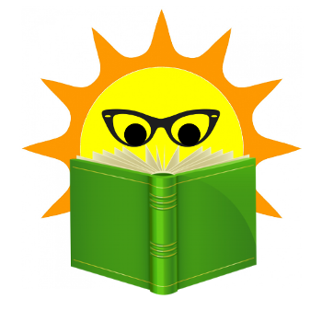  
**Hempstead, NY 11550**